3D Gallery Generator: Helpsheet

▪ Your task is to design a virtual, 3D-Animated museum exhibition on a topic or theme of your choice.
▪ Choose your images and videos carefully: you have space for TEN exhibits.
▪ You can give each exhibit a title and a description for maximum educational effect.
▪ When you have finished you can save your work for future editing, and embed your work into your own website.
▪ Use this template to help you plan your project: your teacher may insist that you complete this sheet before you access the 3D Gallery Generator at http://www.classtools.net/3D.
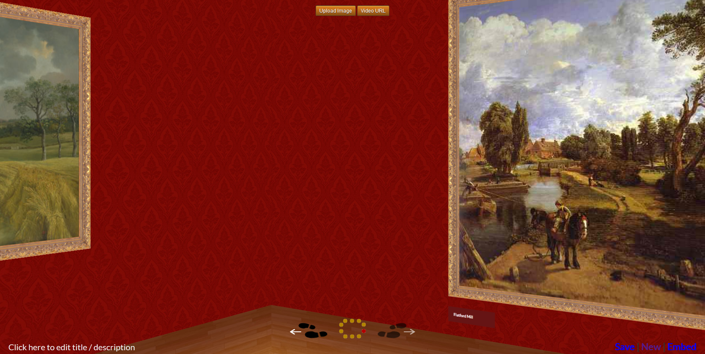
A screenshot giving an impression of the ‘walk-through’ effect

Title of Exhibition
???

TIPS:
▪ The title could be an entire topic, or a narrower focus within it. For example, “The German Weimar Republic” could be instead “Culture of the Weimar Republic” or even “The Art of George Grosz”.
▪ Consider constructing the title in the form of a question to provide added interest: for example, “What are the main characteristics of…?” or “What were the strengths and weaknesses of …?”.

Exhibits to be Displayed

 | Image / Video Link | Caption | Description
1 | ??? | ??? | ???
2 | ??? | ??? | ???
3 | ??? | ??? | ???
4 | ??? | ??? | ???
5 | ??? | ??? | ???
6 | ??? | ??? | ???
7 | ??? | ??? | ???
8 | ??? | ??? | ???
9 | ??? | ??? | ???
10 | ??? | ??? | ???
TIP: Aim for a logical order and a mix of different exhibits (e.g. videos, photographs of objects / scenes / individuals, cartoons, maps etc).

Suggested Markscheme

 |  | Available Marks
Title | The title of the exhibition makes the focus of the gallery clear to the viewer. | 1
Breadth | The gallery contains a variety of appropriate media types (e.g. paintings, video, photos, maps, cartoons) | 3
Depth | Each gallery exhibit has a clear caption and a detailed description to accompany it. | 3
Linkage | There is a logical, methodical order to the way that the exhibits are arranged (e.g. the description for each exhibit clearly picks up from where the last one left off). | 3

