What sort of a man was Napoleon?

In this activity we will try to determine what sort of man Napoleon was. We will try to determine whether he appears the sort of man who would respect, or undermine, the Rights of Man held so dear by the French Revolutionaries.

Stage 1
▪ Prior to the lesson, your teacher will print off these sources and place them on different tables.
▪ The class will be divided into pairs, and each pair will be directed to a different table with a different source.
▪ 2 minutes: Read the source in silence.
▪ 3 minutes: Still in silence, annotate the source by underlining key words / phrases and either (a) Making your observations, or (b) Asking questions, in the margin. Your partner can answer these questions if they wish. During this time, the teacher will move between the groups silently adding extra questions / observations.

TIP: Think about such things as:
Appearance | Temperament | Personality | People skills | Habits

Stage 2
▪ All pairs will now be moved around the class to look at a different source. Repeat the process for as long as you wish. At the end of the process your teacher may lead a discussion about what we have learned about Napoleon so far, covering such questions as “What are his most positive qualities? The most negative? What evidence is there that Napoleon deliberately cultivated his charisma? What are the most obvious differences of opinion? Why do they differ?
▪ The completed sheets should be put on display where they can be compared.

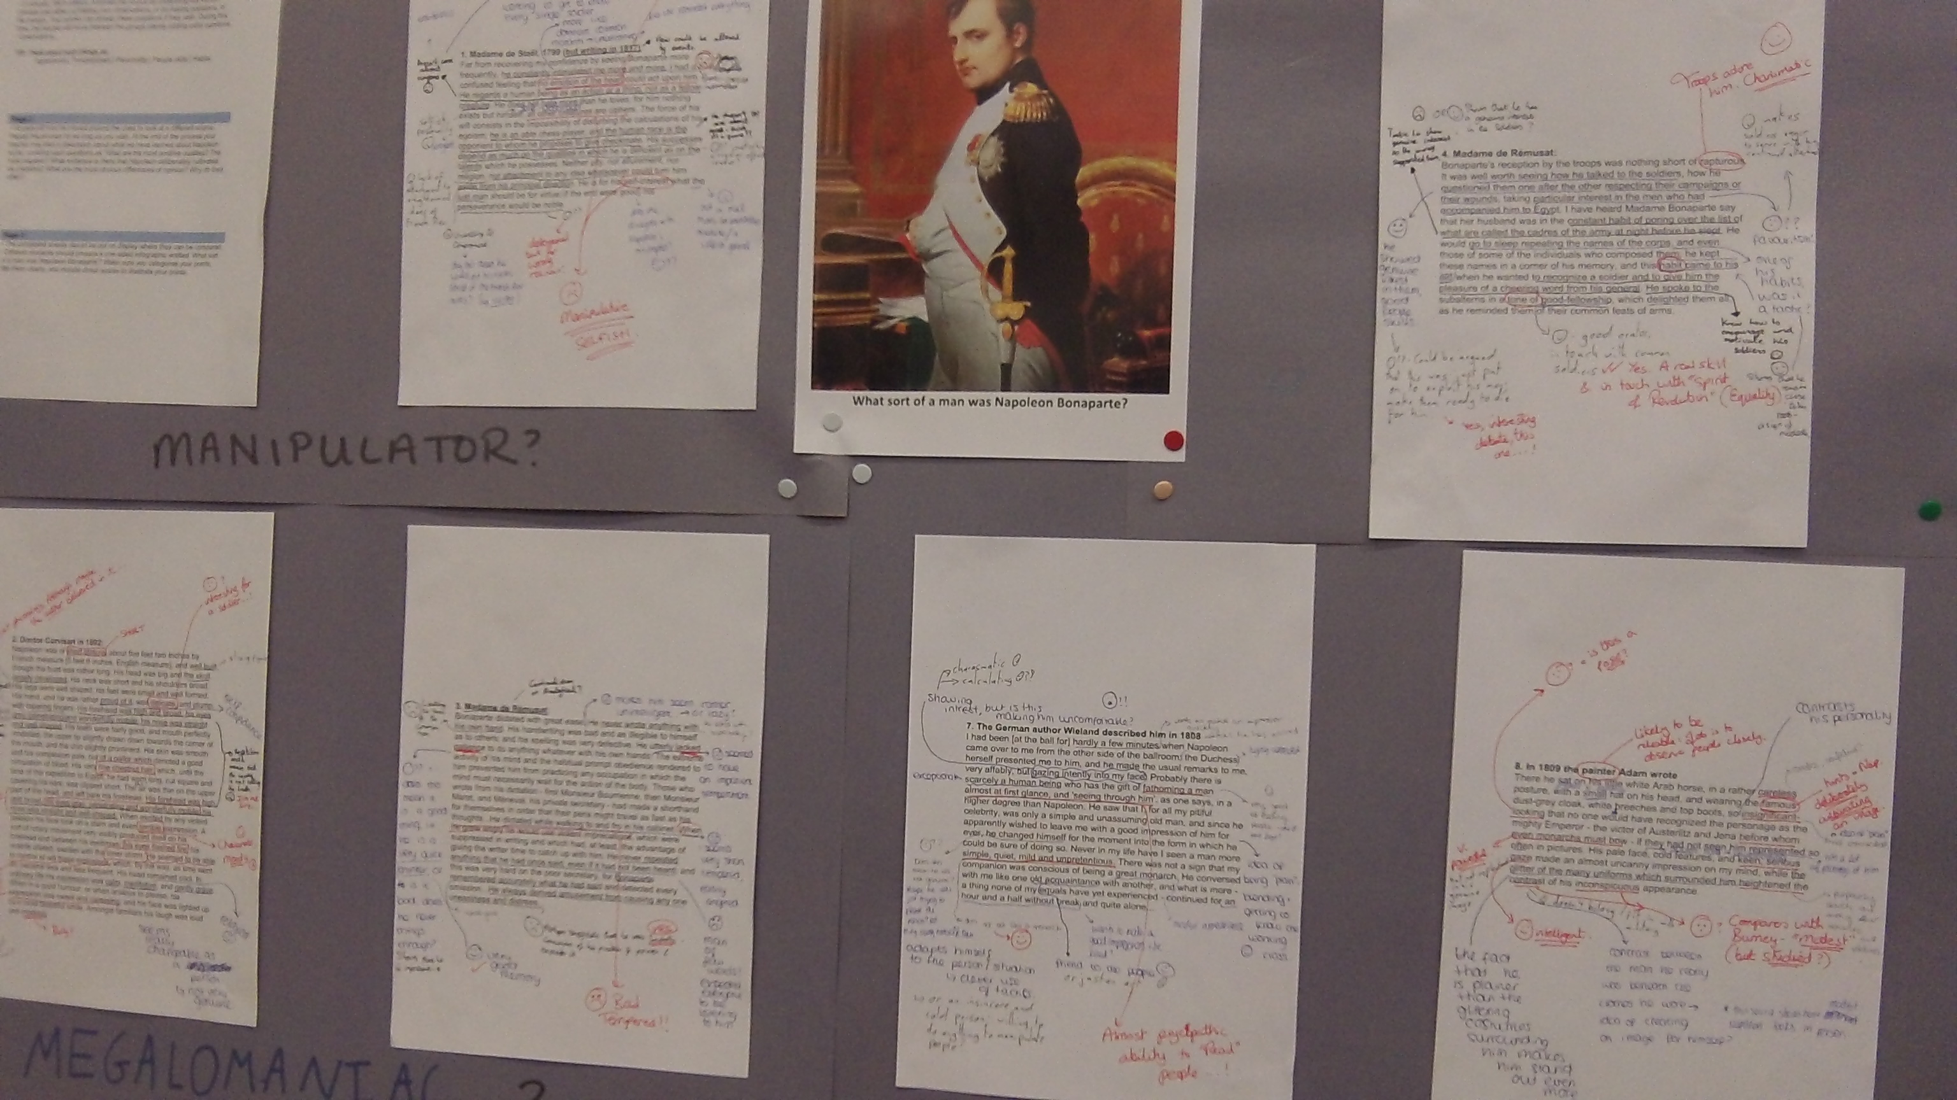

Stage 3
Produce a written answer to the question “To what extent do primary accounts suggest that Napoleon embodied the spirit of the French Revolution?”

0. Napoleon's Proclamation to the Army, May, 1796
Soldiers: You have in fifteen days you have won six victories, taken twenty-one stand of colors, fifty-five pieces of cannon, and several fortresses, and overrun the richest part of Piedmont; you have made 15,000 prisoners, and killed or wounded upwards of 10,000 men. Hitherto you have been fighting for barren rocks, made memorable by your valour, though useless to your country, but your exploits now equal those of the armies of Holland and the Rhine. You were utterly destitute, and you have supplied all your wants. You have gained battles without cannon, passed rivers without bridges, performed forced marches without shoes, and bivouacked without strong liquors, and often without bread. ..The two armies which lately attacked you in full confidence, now fly before you in consternation; the perverse men who laughed at your distress, and inwardly rejoiced at the triumph of your enemies, are now confounded and trembling. But, soldiers, you have yet done nothing, for their still remains much to do… It is said that there are some among you whose courage is shaken, and who would prefer returning to the summits of the Alps and Apennines. No, I cannot believe it. The victors of Montenotte, Millesimo, Dego, and Mondovi are eager to extend the glory of the French name!"

1. Madame de Staël, 1799 (but writing in 1817)
Far from recovering my confidence by seeing Bonaparte more frequently, he constantly intimidated me more and more. I had a confused feeling that no emotion of the heart could act upon him. He regards a human being as an action or a thing, not as a fellow-creature. He does not hate more than he loves; for him nothing exists but himself; all other creatures are ciphers. The force of his will consists in the impossibility of disturbing the calculations of his egoism; he is an able chess-player, and the human race is the opponent to whom he proposes to give checkmate. His successes depend as much on the qualities in which he is deficient as on the talents which he possesses. Neither pity, nor allurement, nor religion, nor attachment to any idea whatsoever could turn him aside from his principal direction. He is for his self-interest what the just man should be for virtue; if the end were good, his perseverance would be noble.

2. Doctor Corvisart in 1802:
Napoleon was of short stature, about five feet two inches by French measure [5 feet 6 inches, English measure], and well built, though the bust was rather long. His head was big and the skull largely developed. His neck was short and his shoulders broad. His legs were well shaped, his feet were small and well formed. His hand, and he was rather proud of it, was delicate, and plump, with tapering fingers. His forehead was high and broad, his eyes gray, penetrating and wonderfully mobile; his nose was straight and well shaped. His teeth were fairly good, and mouth perfectly modelled, the upper lip slightly drawn down towards the corner of the mouth, and the chin slightly prominent. His skin was smooth and his complexion pale, but of a pallor which denoted a good circulation of blood. His very fine chestnut hair, which, until the time of the expedition to Egypt, he had worn long, cut square and covering his ears, was clipped short. The air was thin on the upper part of the head, and left bare his forehead. His forehead was high and broad, his eyes gray, penetrating and wonderfully mobile; his nose was straight and well-shaped. When excited by any violent passion his face took on a stern and even terrible expression. A sort of rotary movement very visibly produced itself on his forehead and between his eyebrows; his eyes flashed fire; his nostrils dilated, swollen with the inner storm. He seemed to be able to control at will these explosions, which, by the way, as time went on, became less and less frequent. His head remained cool. In ordinary life his expression was calm, meditative, and gently grave. When in a good humour, or when anxious to please, his expression was sweet and caressing, and his face was lighted up by a most beautiful smile. Amongst familiars his laugh was loud and mocking.

3. Madame de Rémusat:
Bonaparte dictated with great ease. He never wrote anything with his own hand. His handwriting was bad and as illegible to himself as to others; and his spelling was very defective. He utterly lacked patience to do anything whatever with his own hands. The extreme activity of his mind and the habitual prompt obedience rendered to him prevented him from practicing any occupation in which the mind must necessarily wait for the action of the body. Those who wrote from his dictation - first Monsieur Bourrienne, then Monsieur Maret, and Méneval, his private secretary - had made a shorthand for themselves in order that their pens might travel as fast as his thoughts...He dictated while walking to and fro in his cabinet. When he grew angry he would use violent imprecations, which were suppressed in writing and which had, at least, the advantage of giving the writer time to catch up with him. He never repeated anything that he had once said, even if it had not been heard; and this was very hard on the poor secretary, for Bonaparte remembered accurately what he had said and detected every omission...He always derived amusement from causing any one uneasiness and distress...

4. Madame de Rémusat:
Bonaparte's reception by the troops was nothing short of rapturous. It was well worth seeing how he talked to the soldiers, how he questioned them one after the other respecting their campaigns or their wounds, taking particular interest in the men who had accompanied him to Egypt. I have heard Madame Bonaparte say that her husband was in the constant habit of poring over the list of what are called the cadres of the army at night before he slept. He would go to sleep repeating the names of the corps, and even those of some of the individuals who composed them; he kept these names in a corner of his memory, and this habit came to his aid when he wanted to recognize a soldier and to give him the pleasure of a cheering word from his general. He spoke to the subalterns in a tone of good-fellowship, which delighted them all, as he reminded them of their common feats of arms.

5. Molé, presiding at the Council of State:
Sitting deep in the armchair from which he presided...the little gold snuffbox which he was constantly and automatically opening to take pinches of tobacco which he breathed in noiselessly and most of which fell back on the white lapels of his uniform which were soon covered with it, finally the mechanical movement of his arm to hand the snuffbox to the chamberlain standing behind him who filled it and gave it back to him. All that defined him so strongly as a man meditating in solitude that all eyes were on him but the silence was unbroken...

6. Dennis Davidov's description of Napoleon at Tilsit (where he signed a peace agreement with Russia) in 1807
I have already remarked on how much I was struck by the overall resemblance of Napoleon to the prints on sale everywhere. But the same was not true of his facial features. None of the portraits that I had seen bore the least resemblance to him. Believing them, I had supposed that Napoleon sported a rather large hooked nose, dark eyes and dark hair - in a word, the true Italian facial type. In fact, his face was slightly swarthy, with regular features. His nose was not very large, but straight, with a very slight, hardly noticeable bend. The hair on his head was not black, but dark reddish-blond; his eyebrows and eyelashes were much darker than the colour of his hair, and his blue eyes, set off by the almost black lashes, gave him a most pleasing expression. Finally, no matter how many times I had occasion to see him, I never noticed those frowning eyebrows with which the portrait-pamphleteers endowed him. The man I saw was of short stature, just over five feet tall, rather heavy although he was only 37 years old and despite the fact that the lifestyle he followed should not, on the face of it, have let him put on much weight. He held himself erect without the least effort, as is common with all short people. But what was peculiar to him alone was a nobility of bearing and an urbane, martial air, which undoubtedly was derived from the habit of commanding men and a consciousness of moral superiority. No less remarkable were the ease and frankness of his approach, his natural dexterity and the quickness of his movements.

7. The German author Wieland described him in 1808
I had been [at the ball for] hardly a few minutes when Napoleon came over to me from the other side of the ballroom; the Duchess herself presented me to him, and he made the usual remarks to me, very affably, but gazing intently into my face. Probably there is scarcely a human being who has the gift of fathoming a man almost at first glance, and 'seeing through him', as one says, in a higher degree than Napoleon. He saw that I, for all my pitiful celebrity, was only a simple and unassuming old man, and since he apparently wished to leave me with a good impression of him for ever, he changed himself for the moment into the form in which he could be sure of doing so. Never in my life have I seen a man more simple, quiet, mild and unpretentious. There was not a sign that my companion was conscious of being a great monarch. He conversed with me like one old acquaintance with another, and what is more - a thing none of my equals have yet experienced - continued for an hour and a half without break and quite alone...

8. In 1809 the painter Adam wrote
There he sat on his little white Arab horse, in a rather careless posture, with a small hat on his head, and wearing the famous dust-grey cloak, white breeches and top boots, so insignificant-looking that no one would have recognized the personage as the mighty Emperor - the victor of Austerlitz and Jena before whom even monarchs must bow - if they had not seen him represented so often in pictures. His pale face, cold features, and keen, serious gaze made an almost uncanny impression on my mind, while the glitter of the many uniforms which surrounded him heightened the contrast of his inconspicuous appearance.

9. The Russian Baron von Lowenstern first met Napoleon in Vienna in 1809:
Finally, I was able to see this man! I really must say that as I approached him, in no way did he make the impression on me that I had anticipated. I found him more corpulent that he is usually portrayed. His gait was hardly gracious, his manner lacking honour.

10. A German teacher in Dusseldorf in 1811
The Emperor's face was turned to us in profile, when he bent forward to listen to the President's welcoming speech. Its pure, classical outline reminded one strongly of the busts of the [Roman] Emperor Augustus. It was certainly very imposing....There was also something friendly about it at the moment he was listening to the speech, and he must, I think, have been in a kinder and more gentle frame of mind that day. The impression which he left on me was not at all the repulsive one which I had really expected, and I was glad of it; for though a world-shattering greatness might appear in an outwardly disgusting form, it would be incredible that thousands should be taken in by it, and a whole nation actually carried off its feet with enthusiasm.

11. First Capt. Ross, commander of the Northumberland, 1815
He is fat, rather what we call pot-bellied, and although his leg is well shaped, it is rather clumsy, and his walk appears rather affected, something between a waddle and a swagger-but probably not being used to the motion of a ship might have given him that appearance. He is very sallow, with light grey eyes, and rather thin, greasy-looking brown hair, and altogether a very nasty, priestlike-looking fellow....He never gave the smallest trouble to anyone, and every day was the same; he was very communicative, and seemed fond of being asked questions; his manners are by no means good, and his voice very harsh and unpleasing.

12. Sir George Bingham, also aboard the Northumberland, 1815
He was dressed in a plain green uniform, with plain epaulets, white kerseymore waistcoat and breeches, with stockings, and small gold shoe-buckles, his hair out of powder and rather greasy, his person corpulent, his neck short, and his tout ensemble not at all giving an idea that he had been so great or was so extraordinary a man.

