Round 1 | 1 |  |  | Balloon Debate: Knockout Template!  This template organises a competition between 16 finalists. If there are more than 16 competitors to start with, create several large balloons (e.g. of 5 characters each). The characters in the first balloon have 30 seconds each to summarise why they deserve to stay in the competition. The rest of the class votes on which character(s) should be ejected.  Repeat for the other balloons until you have 16 finalists. |  |  |  |  |  |  | 9 | Round 1
 | 2 |  |  |  |  |  |  |  |  |  | 10
 |  | Quarter  Final | 1 or 2 |  |  |  |  |  | 9 or 10 | Quarter Final
 |  |  | 3 or 4 |  |  |  |  |  | 11 or 12
Round 1 | 3 |  |  |  | 1,2,3 or 4 | Semi-Final | 9,10,11 or 12 |  |  |  | 11 | Round 1
 | 4 | 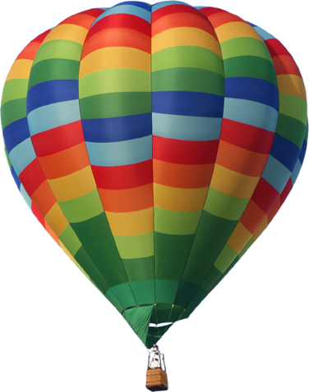 |  |  |  |  |  |  |  |  | 12
 |  |  |  |  |  | ?
 |  |  |  |  |  | FINAL!
 |  |  |  |  |  | ?
Round 1 | 5 |  |  |  |  |  |  |  |  |  | 13 | Round 1
 | 6 |  |  |  | 5,6,7 or 8 | Semi-Final | 13,14,15 or 16 |  |  |  | 14
 |  | Quarter Final | 5 or 6 | TIPS  • Make sure that in each round, competitors have to focus on a different theme: otherwise, they merely end up saying the same things several times in different rounds and it gets repetitive. For example:  Round 1: Focus on short-term significance, in their own lifetimes  Quarter Final: Focus on long-term significance, up to the modern day  Semi-Final: Appealing details about their private life / personality  Final: Focus on weaknesses of the other finalist (after further research). |  |  |  |  | 13 or 14 | Quarter Final
 |  |  | 7 or 8 |  |  |  |  |  | 15 or 16
Round 1 | 7 |  |  |  |  |  |  |  |  |  | 15 | Round 1
 | 8 |  |  |  |  |  |  |  |  |  | 16
For scores more free ideas and downloads, check out Tarr’s ToolBox at ClassTools.net

