You are invited to the wedding of
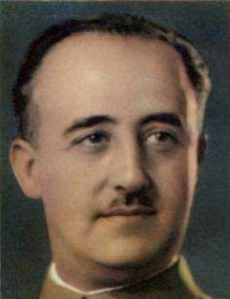 | Franco | & | Pinochet
 | Dictator of Spain, 1939-75 |  | Dictator of Chile, 1973-1990
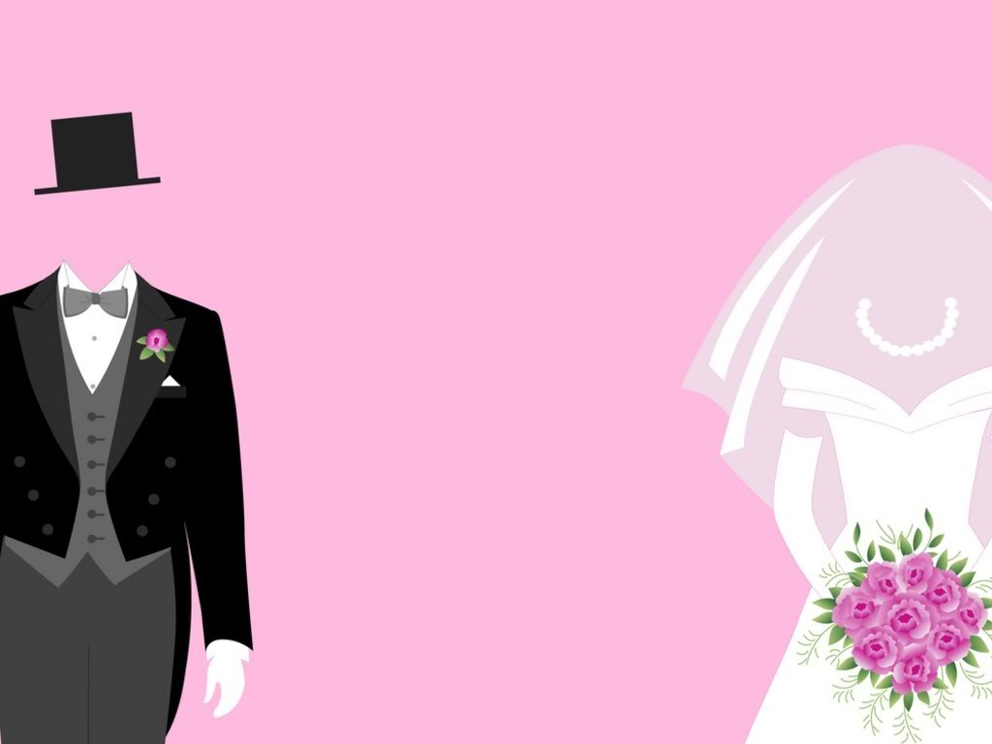
“With military precision love did grow
Catholic tradition was strongly in tow;
Hatred of democrats, reds and pinks
Plus anti-charisma: our common links”
Ceremony: Madrid, 1939 | Santiago, 1973: Evening reception

Formal mililtary dress required. White bread for all guests. Best man: Mola Sanjurjo Jose Antonio TO BE DECIDED
The bride and groom would like to thank the United States of America for their sponsorship of this event.

